Energy and Place Inspiration Journal Assignment #1
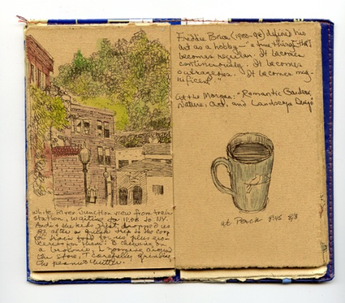
“Everybody is talented, original and has something important to say…Everybody is original if he tells the truth and if he speaks from himself. But it must be from his true self and not from the self he thinks he should be”- Brenda Ueland
“And by the way, everything in life is writable about if you have the outgoing guts to do it, and the imagination to improvise. The worst enemy to creativity is self-doubt.” – Sylvia Plath
WHAT Get a cool journal. The more tattered, loved or worn the better. If you must just use your spiral notebook, fine! But you will be missing out on an opportunity to cultivate a clandestine relationship with a sacred object that one day your grandchildren will uncover on a dusty attic shelf and be in awe of your insights and potentially scandalous young adults years.

WHY
You will be using the journal for responses to various writing prompts designed to get you to make thoughtful observations of the interactions between man and nature, and to collect photographs and images that might help inspire ideas for your final sense of place writing assignment. This is just the FIRST journal assignment that we’ll do on our desert camping trip to channel the spirit of Edward Abbey. All y’all who sadly can’t join us need to do this assignment sometime before Monday, April 25th.

Assignment #1: “Details, details, details”
Find a spot that you find beautiful OUTDOORS. Write down every sight, sound, touch, smell. Observe everything around you in as much detail as possible. Don’t stop writing for 30 minutes. When you think you have nothing else to write, look closer, listen closer. Reflect on how your presence impacts the setting you’re observing. Next, reflect on how this setting influences YOU (your state of mind, your energy level, your physical condition, etc...).
If you’re still really stuck and there is still time left (there is ALWAYS time left for thoughtful reflection and quiet contemplation of your surroundings) then start to imagine what this environment would look like with some type of energy production development (oil extraction, wind farm, solar array field, uranium mine, nuclear power plant). How would all of this that you are observing change? What sort of changes? Would you welcome those changes? Why or why not?
Some Tips for Writing:
- Just let the writing flow. You don’t need to censor, edit or judge.
- Try to use active verbs: instead of “is” and “have”. Verbs not adjectives really make a piece move and come alive. Example: Instead of “the jaguar is a predator and has big teeth,” something like “the jaguar stalks the jungle and its teeth can rip apart a young deer in mere seconds.”
- Try to vary the lengths of sentences. This adds rhythm and drama to your writing, which helps hold the reader’s attention. Example: “Finally John decided to marry the big beautiful gorilla that had been waiting in the back yard. About time!”
- Try to use details (Sensory images): SHOW us details. Gory, raw, specific details. Example: Instead of “I wasn’t sure what to think of my new haircut,” something like “The sounds of hair dryers and whispering women grew dim in comparison to the big question resounding in my head: What the hell have I done?”

